

**CyberSec Tracker**

**Submitted by:**

**Kishor.M - 22BTAI172**

**Manasa P M – 22BTAI174**

**Ruipth Kumar N – 22BTAI198**

**Prapul T – 22BTAI200**

**Brenton M Jerry – 22BTAI211**

**GitHub Link -**

**Course: Full Stack Development Course Code: 10ABTEC24514**

**Submitted To: Prof. Chinta Indira Devi**

**Date of Submission: 14/01/2025**

**Table of Contents**

1. **Introduction**
2. **Project Overview**
3. **Technology Stack**
4. **System Architecture**
5. **Implementation**
6. **Conclusion**
7. **References**

**Introduction**

**Background of the Project:**

The rapid growth of the digital ecosystem has brought unparalleled convenience to individuals and organizations. However, this progress has also made them increasingly vulnerable to an array of cyber threats, including data breaches, ransomware attacks, and advanced persistent threats (APTs). To address this critical issue, **CyberSec Tracker** was envisioned as a solution to empower users with real-time insights and actionable intelligence for enhanced cybersecurity.

With the need for a centralized platform to monitor, detect, and respond to emerging threats, **CyberSec Tracker** aims to bridge the gap between sophisticated cyber defense tools and the accessibility required by non-technical users and businesses.

**Objectives:**

* **Real-Time Threat Monitoring:** Provide users with a live threat map that visualizes global cyberattacks and highlights high-risk zones.
* **Proactive Alerts:** Deliver timely alerts on emerging vulnerabilities, zero-day exploits, and other critical cybersecurity events.
* **Comprehensive Insights:** Offer industry-specific reports to help users understand trends and threats relevant to their sectors.
* **User Empowerment:** Enhance user awareness and readiness through security recommendations and best practices.

**Scope of the Project:**  
The **CyberSec Tracker** project focuses on building a versatile and user-friendly cybersecurity platform for individuals and small-to-medium-sized enterprises (SMEs). The platform will integrate advanced cybersecurity features, including:

1. **Live Threat Visualization:** A dynamic map showcasing global cyber threats and attack vectors.
2. **Alerts System:** A robust alert mechanism to inform users of critical threats and vulnerabilities in real time.
3. **Industry-Specific Reports:** Tailored insights and reports for various sectors, such as healthcare, finance, and education.
4. **Educational Resources:** Comprehensive guides and tips to improve cybersecurity awareness.
5. **User Engagement Features:** Subscription services for weekly summaries and personalized threat updates.

**Project Overview**

**Description of the Project:**

**CyberSec Tracker** is an advanced cybersecurity platform designed to act as a personal and organizational guardian against emerging cyber threats. The platform combines cutting-edge technologies with user-centric design to deliver robust protection, enabling users to safeguard their digital assets and sensitive information effectively. By integrating real-time monitoring and proactive measures, CyberSec Tracker ensures a secure online experience for its users.

**Key Features and Functionalities:**

* **Threat Detection:** Continuously monitors and detects potential security threats in real-time, offering immediate alerts and insights.
* **Data Breach Alerts:** Keeps users informed about breaches that may compromise their accounts, helping them take prompt action.
* **Proactive Recommendations:** Delivers tailored advice to fortify security measures, minimizing vulnerabilities.
* **User-Friendly Dashboard:** Provides an intuitive interface that simplifies the management of cybersecurity for both individuals and organizations.
* **Industry-Specific Insights:** Offers detailed reports and analytics tailored to specific industries, such as healthcare, education, and finance.

**Target Audience:**

* **Individuals:** Tech-savvy users and general users looking for reliable and personal cybersecurity solutions to protect their digital lives.
* **Small and Medium-Sized Enterprises (SMEs):** Businesses seeking affordable, scalable, and effective cybersecurity solutions to safeguard their data and operations without the need for specialized IT expertise.

**Technology Stack**

* **Frontend:**Use of HTML, CSS and SVG for dynamic and responsive user interfaces.
* **Backend:** Node.js with Express.js for efficient server-side operations.
* **Database:** MongoDB for secure and scalable data storage.
* **Additional Tools:**
  + JWT for authentication and user management.
  + REST APIs for seamless data flow between frontend and backend.
  + Python for threat detection algorithms.

**System Architecture**

**High Level Architecture Diagram:**

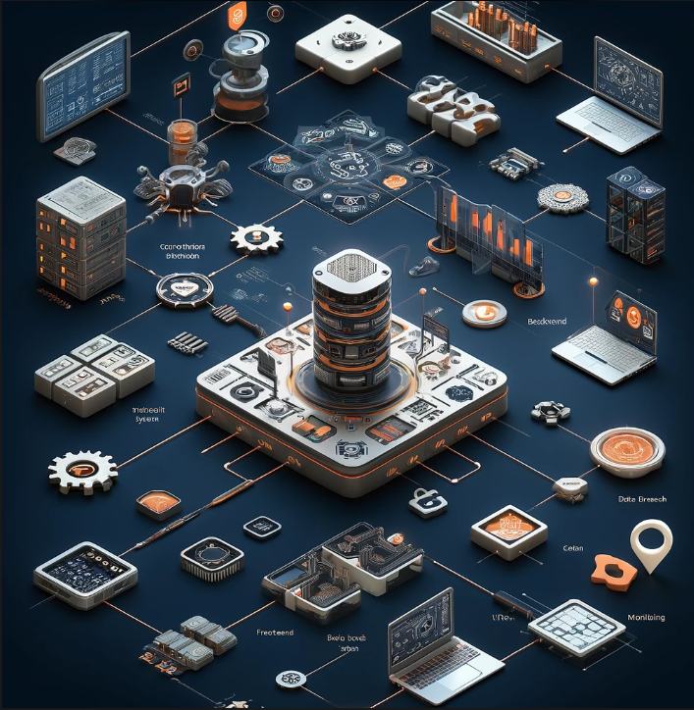

**Data Flow and Interaction Between Components:**

1. The frontend communicates with the backend using REST APIs to send and retrieve data.
2. The backend processes requests, executes algorithms, and interfaces with the MongoDB database for storing user data and threat logs.
3. The system monitors external cybersecurity feeds to update users on new threats.

**Implementation**

The project is implemented as a web application where users can log in to a secure dashboard. The backend is responsible for handling authentication, threat detection, and real-time updates. The database securely stores user credentials, threat logs, and breach reports. Integration with external APIs ensures up-to-date threat intelligence.

**Code Snippets of the Project:**

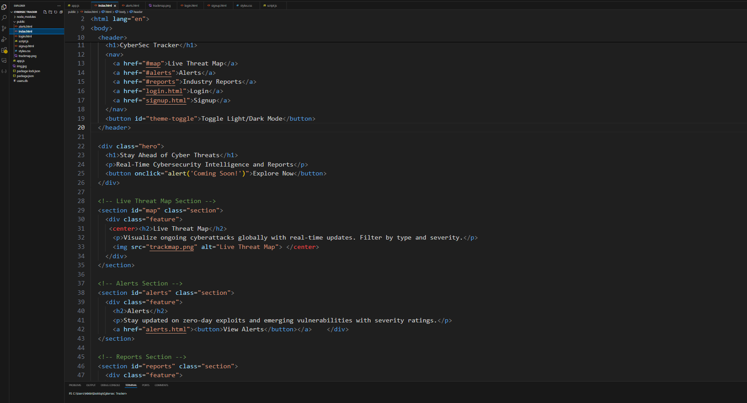

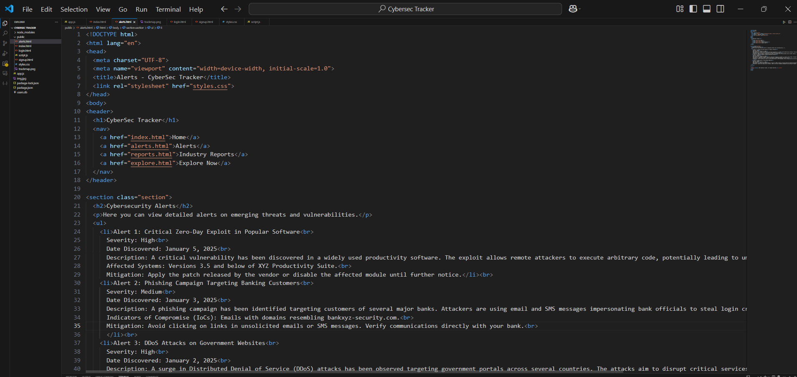

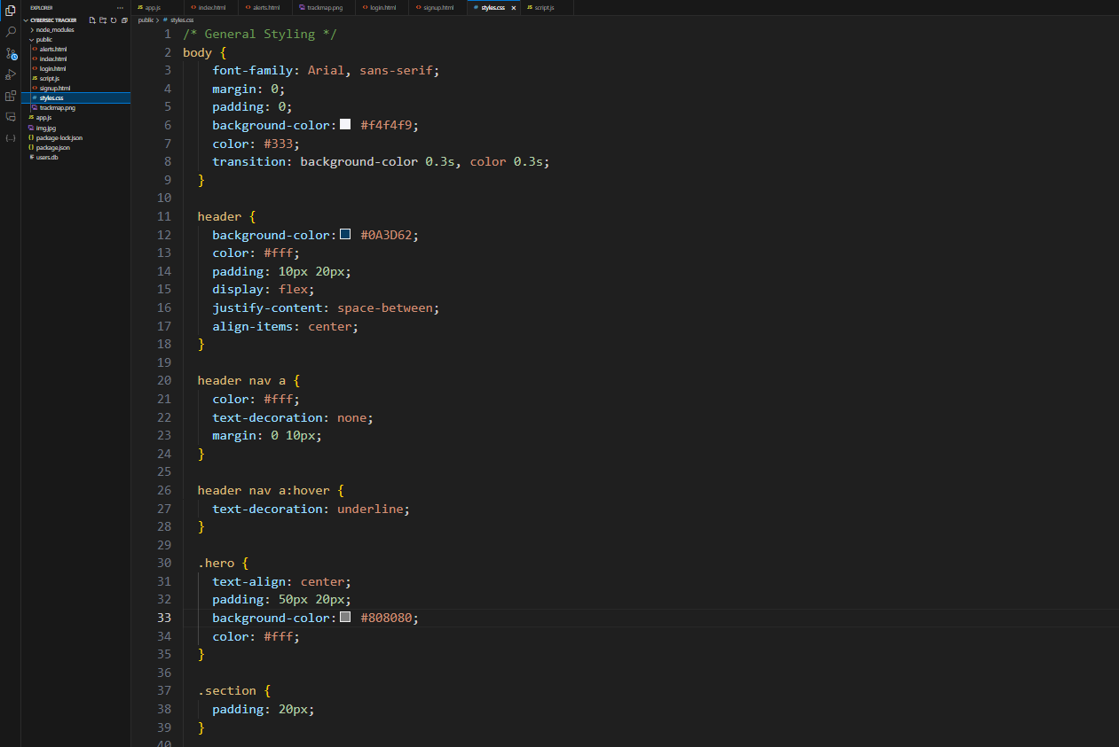

**Screenshots of the Project:**

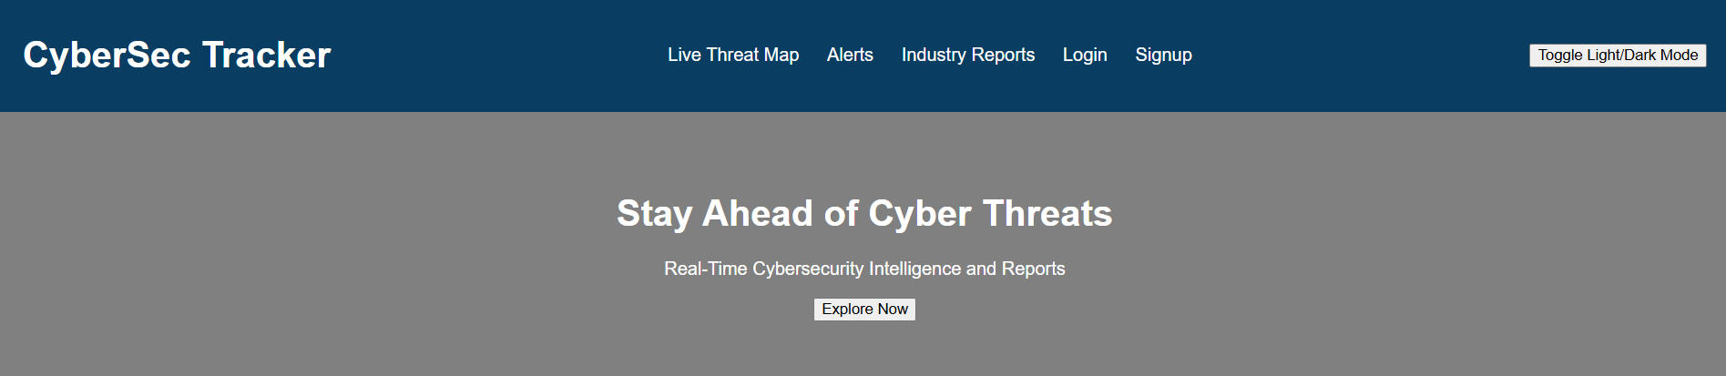

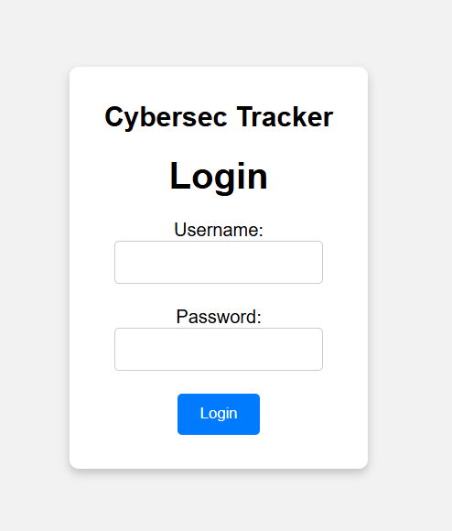

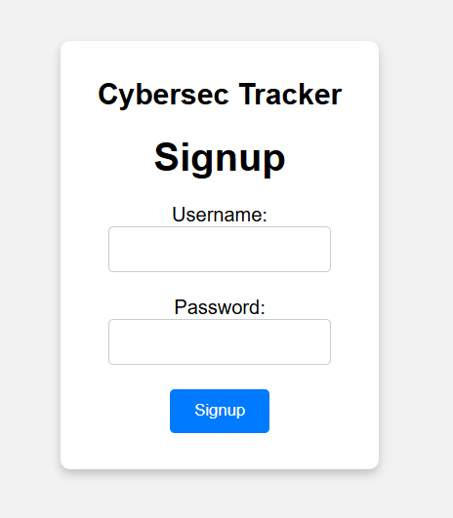

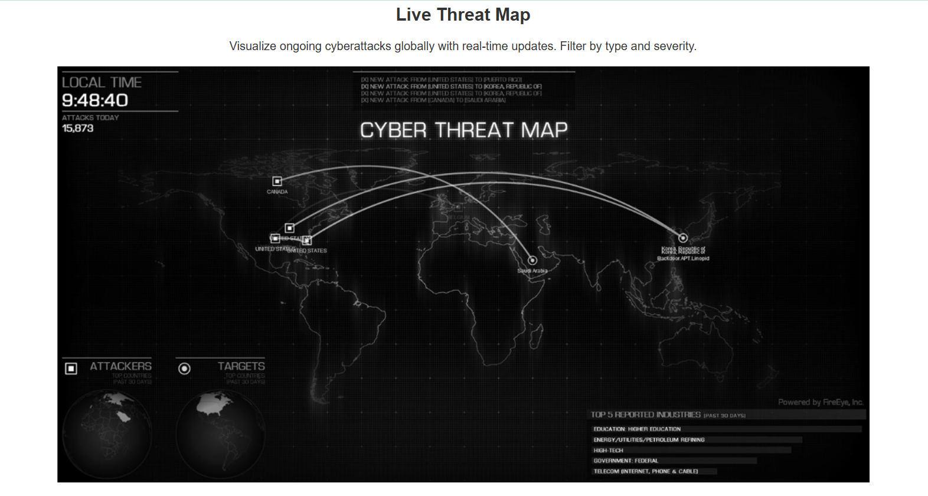

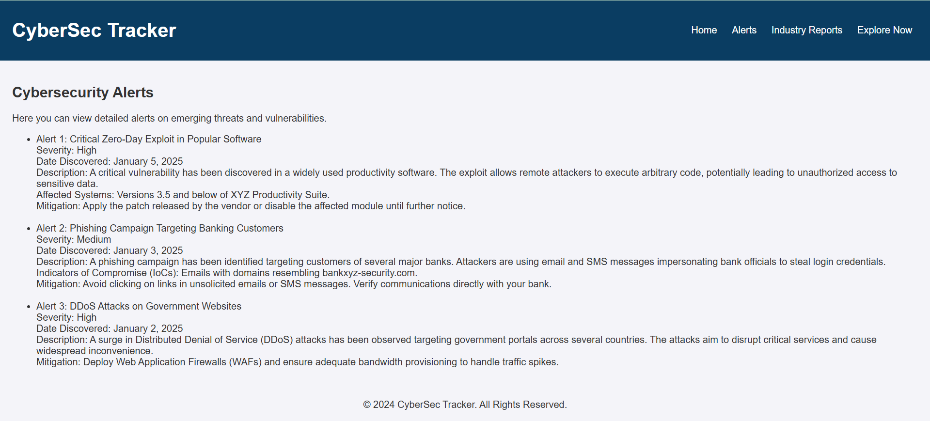

**Conclusion**

**CyberSec Tracker** is a comprehensive and innovative platform designed to address the ever-growing challenges of cybersecurity. By combining advanced threat detection, real-time alerts, and proactive recommendations, it empowers individuals and small-to-medium-sized enterprises (SMEs) to safeguard their digital assets effectively. With its user-friendly interface and robust backend, CyberSec Tracker ensures that even users with minimal technical expertise can stay protected in an increasingly complex digital landscape.

The platform’s modular design and integration capabilities pave the way for future enhancements, such as AI-driven analytics and seamless interoperability with third-party tools. As the cybersecurity landscape continues to evolve, **CyberSec Tracker** is committed to staying ahead of threats, ensuring users are well-equipped to protect their data and systems.

By delivering accessible, reliable, and forward-thinking solutions, CyberSec Tracker positions itself as an essential tool for anyone looking to enhance their digital security in today’s interconnected world.

**References**

* **OWASP (Open Web Application Security Project)**  
  Official website: <https://owasp.org>  
  Resource for web application security best practices and guidelines.
* **NIST (National Institute of Standards and Technology)**  
  NIST Cybersecurity Framework: <https://www.nist.gov/cyberframework>  
  Comprehensive guidance on improving cybersecurity risk management.
* **IBM X-Force Exchange**  
  Threat Intelligence Platform: https://exchange.xforce.ibmcloud.com  
  Source of global threat intelligence for tracking emerging cyber threats.
* **CISA (Cybersecurity and Infrastructure Security Agency)**  
  Alerts and Recommendations: <https://www.cisa.gov>  
  Updates on vulnerabilities, threats, and mitigation strategies.